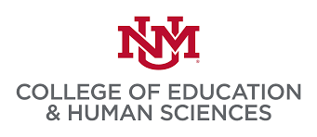
American Indian Language Policy Research & Teacher Training Center University of New Mexico

NATIVE AMERICAN LANGUAGE TEACHERS’ INSTITUTE (NALTI)
June 6-17, 2022

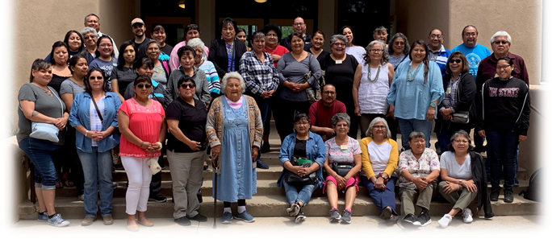

DESCRIPTION: This two-week in-person institute will address key foundations for teaching Native American languages in community and school-based programs. A special day will be devoted to issues of Early Childhood Education and implications for supporting Native language development among this age group. Native language speakers who teach or who are planning to teach their language are especially encouraged to attend.
Classes meet daily from 9AM -4PM in Albuquerque at the University of New Mexico. Seating is limited. Get your registrations in early to reserve your place!
For more information, contact Dr. Christine Sims at: csims@unm.edu
Submission Deadline is May 27th, 2022. Notification by May 31st, 2022
OPTIONAL COURSE CREDIT AVAILABLE
*Option of earning 3 Hrs. of undergraduate (LLSS) or graduate course credit is available. If you are not a current UNM student you will need to first apply for UNM admission and submit a fee to UNM. Once this step is complete, you will be able to register for course credit. Follow this link for directions to complete UNM Admissions application: https://www.unm.edu/apply/.
Tuition Scholarships are available on a first come first serve basis!!!!

Directions for Applying to NALTI 2022
There is no cost for attending NALTI, however, we do provide a Course Credit Option, which is explained on page 3 of this announcement. A limited number of tuition scholarships are available for this option on a first-come, first-serve basis.
Directions for registering:

- All interested participants must fill out the NALTI registration form provided on page 2; this includes those who are interested in earning college credits.
  - Download the form, complete it, and click “Save as.”
Return the completed form to Estefanita Calabaza at elcala27@unm.edu.
- If interested in earning college credit, please go to direction number 2 below.

- To receive UNM course credit, please register to UNM by following the steps provided on page 4 of this notice.

ALL applicants are required to fill out the following form, including those taking the Course Credit Option. Please return this form by May 27, 2022, to Estefanita Calabaza at elcala27@unm.edu.
NALTI 2022 APPLICATION
Name:_______________________________________________________________________________
Tribal Affiliation: ________________________________Native Language: ____________________
Your mailing address: ___________________________________________________________________
Email address:_________________________________________________________________________
Phone number________________________________________________________________________
School or Program you work with: ______________________________________________________
Your current role/position: ______________________________________________________________
Grade or Age levels you teach in your language: _______________________________________
How long have you taught your language: ________________________________________________
Do you currently hold a NM 520 Alternative Certificate for teaching a Native language? ___YES ____NO
Have you attended NALTI sessions before? ________YES __________NO In what year(s)?:
Are you interested in obtaining course credit? __________YES _______________NO
If YES, (Check √) ________ Undergraduate credit? OR _________ Graduate credit?
Will you need tuition scholarship assistance? __________YES _________NO
You will be notified of acceptance into NALTI 2022 no later than May 31, 2022.

Do NOT Write Below this line – AILPRTTC USE ONLY
Date Received ______________________Initial ____________________
NALTI Participant No. _____________OR NALTI Wait List No. _______________________

OPTIONAL COURSE CREDIT AVAILABLE
COURSE TITLE/NUMBER: LLSS 449: TEACHING THE NATIVE LANGUAGE
Undergraduate credit: (CRN #29569) (SECTION 001)
Graduate credit: LLSS 593 (CRN #29397) (SECTION 001)
Course Instructor: Dr. Christine Sims
Department of Language, Literacy & Sociocultural Studies
For Course Information contact: csims@unm.edu Cell: (505)681-4008
For technical assistance navigating UNM admission/registration
contact: https://admissions.unm.edu/

For Undergraduate course credit:
- If you are a current UNM student, please contact Dr. Sims at csims@unm.edu for a course override authorization; after which you may register for the course. The information you will need is: Course # (LLSS 449), CRN # (29569), and Section #(001).
- If you are NOT a UNM student (meaning you do not have a UNM Banner ID number) you will need to apply and register as a Non-degree student. Please contact Dr. Sims beforehand at csims@unm.edu to assist you in completing the three-step process, explained below. This process takes additional weeks to complete, so we strongly urge you to begin this process immediately as many students will be applying to summer school.

For Graduate course credit: Please contact Dr. Sims at csims@unm.edu for permission to register for the course under a different Course# (LLSS 593), CRN #29397 and Section# (001). If you are NOT a current UNM Graduate student (meaning you do not have a UNM Banner ID number) you will need to apply and register as a Non-degree Graduate student. This process can take additional weeks to complete, so we strongly urge you to begin this process immediately.

The 3-step process to apply ONLINE at UNM as a Non-degree UNM Student:

- First apply and complete at non-degree UNM admission application (undergraduate or graduate) and submit the required admission fee to UNM Admissions Office BEFORE you attempt to register for the course $25, estimated
- You may obtain an application and further information from the UNM Admission Office by calling 277-2447 or toll free at 1-800-225-5866.
- Application can also be downloaded from the UNM website at http://apply.unm.edu

- Once you are notified by UNM Admissions that you are cleared to register you will be assigned a personal UNM PIN number. If you have indicated you need scholarship assistance to pay for the course, please contact Dr. Sims when you have been admitted to UNM to check on funding availability. Your PIN# will be needed to complete course registration so don’t lose that number!!!
- Estimated tuition cost: $1,008 for 3 hrs. undergraduate and Graduate credit
- UNM Registrar’s Fee: $173.34
- College of Education new admit fee: $125.00

- When you are ready to register, follow the ONLINE directions precisely using the I-TEL-UNM system. Failure to do so may delay your registration. You will need:
  - Your PIN#
  - The Course information provided above (Course #, CRN #, SECTION #)

